# Zomato - Market and Consumer Analysis

# UsingRstudio

**Bita Faraji**

**Yangyang Jia**



**A) Dataset URL's:**

<https://www.kaggle.com/shrutimehta/zomato-restaurants-data/data>

This URL's contain the entire data regarding the Zomato, It is an online website which provides restaurant search and discovery service. It provide its customer a platform to evaluate choices for great place to eat We are curious to study and analyse this huge dataset to understand the buyers' point of view, preferences and their ability to spend. The dataset has total 21 columns and contains the information like, Restaurant ID, Restaurant Name, Country Code, City, Address, Locality, Locality Verbose, Longitude, Latitude, Cuisines, Average Cost for two, Currency, Has Table booking, Has Online delivery, Is delivering now, Switch to order menu, Price range, Aggregate rating, Rating colour, Rating text, Votes. The study will give us the in detail idea about Market and Consumer Analysis – Zomato. It is important to study this Zomato market penetrating into sectors which introducing different [Cuisines, country code, locality longitude latitude, with various currency] Now to study the impact on about the market which the TOP 10 RESTAURANT’S, the average cost of two for the aggregate rating, customer vote, their price range and currency, customer votes and aggregate rating

Before knowing the reason for the choosing this topic, lets know about:- Zomato. It is an online restaurant guide; it is one of the fastest ways to search places to eat. Searching with autonomous reviews and rating where “FoodieBay” it’s the initial name of Zomato started in July 2008 by IIT graduates Mr. Deepinder Goyal (Founder) and Pankaj Chaddah (Co-Founder). Zomato has its headquarters in Delhi. “Info edge” it’s the parent company of Zomato where it was categorised in “mobile applications” and “food and restaurant guide” is its sector. It was renamed as Zomato in November 2010. It expand to Pune and Bangalore and then to Chennai, Ahmadabad and Hyderabad in 2011. In a very short span of time, Zomato went global and started providing its service in Dubai in September 2012. As the company is going more and more global, it rebranded its logo that so that it could transcend cultures, languages and geographic boundaries.

Mission statement of the Zomato states that “Our mission is to ensure nobody has a bad meal”. Vision statement of the Zomato states that “Zomato is used by millions every day to decide where to eat in over 10,000 cities across 23 countries. In a few years, we should be able help point you to a great place to eat no matter what part of the world you're in”.

To differentiate themselves from their competitors. Zomato concentrated on adding approx. 18,000 new places to eat from. Along with they also decorated many special features such as pointed to particular dishes or opening times.

To be the largest resource in food supply market, Zomato bought urban spoon, a leading restaurant service providing portal for $52 million to enter US, Canada and Australia to leverage local insights and experiences and to expand their business in overseas seeing the future goal and objectives.

Finally, the reason in choosing this topic is to have a better insight on how the Zomato's service will affect on the customer in different parts of the world. Also, how customer review will help Zomato improve their services. The analysis will help categorizing restaurants, their locations, quality, etc. and will help to understand user requirement and increase customer satisfaction. As an objective we also need to know about the customers likes and dislikes with respect to places and locality to improve the quality of services accordingly.

**Justifying Columns To Analyze :**

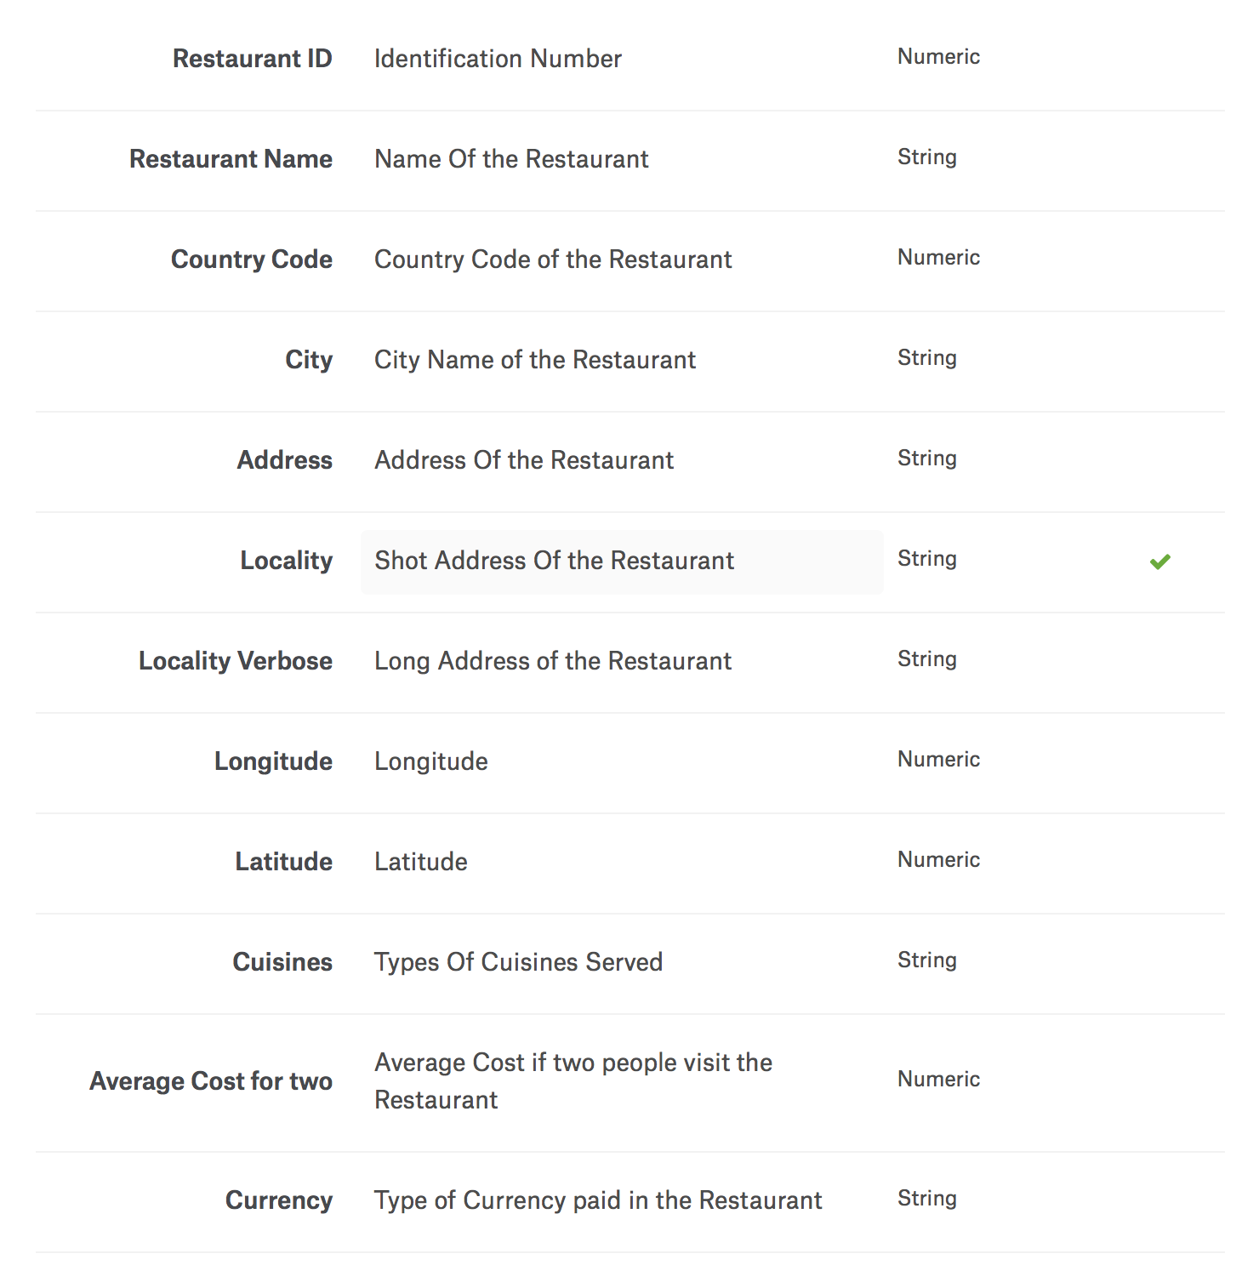

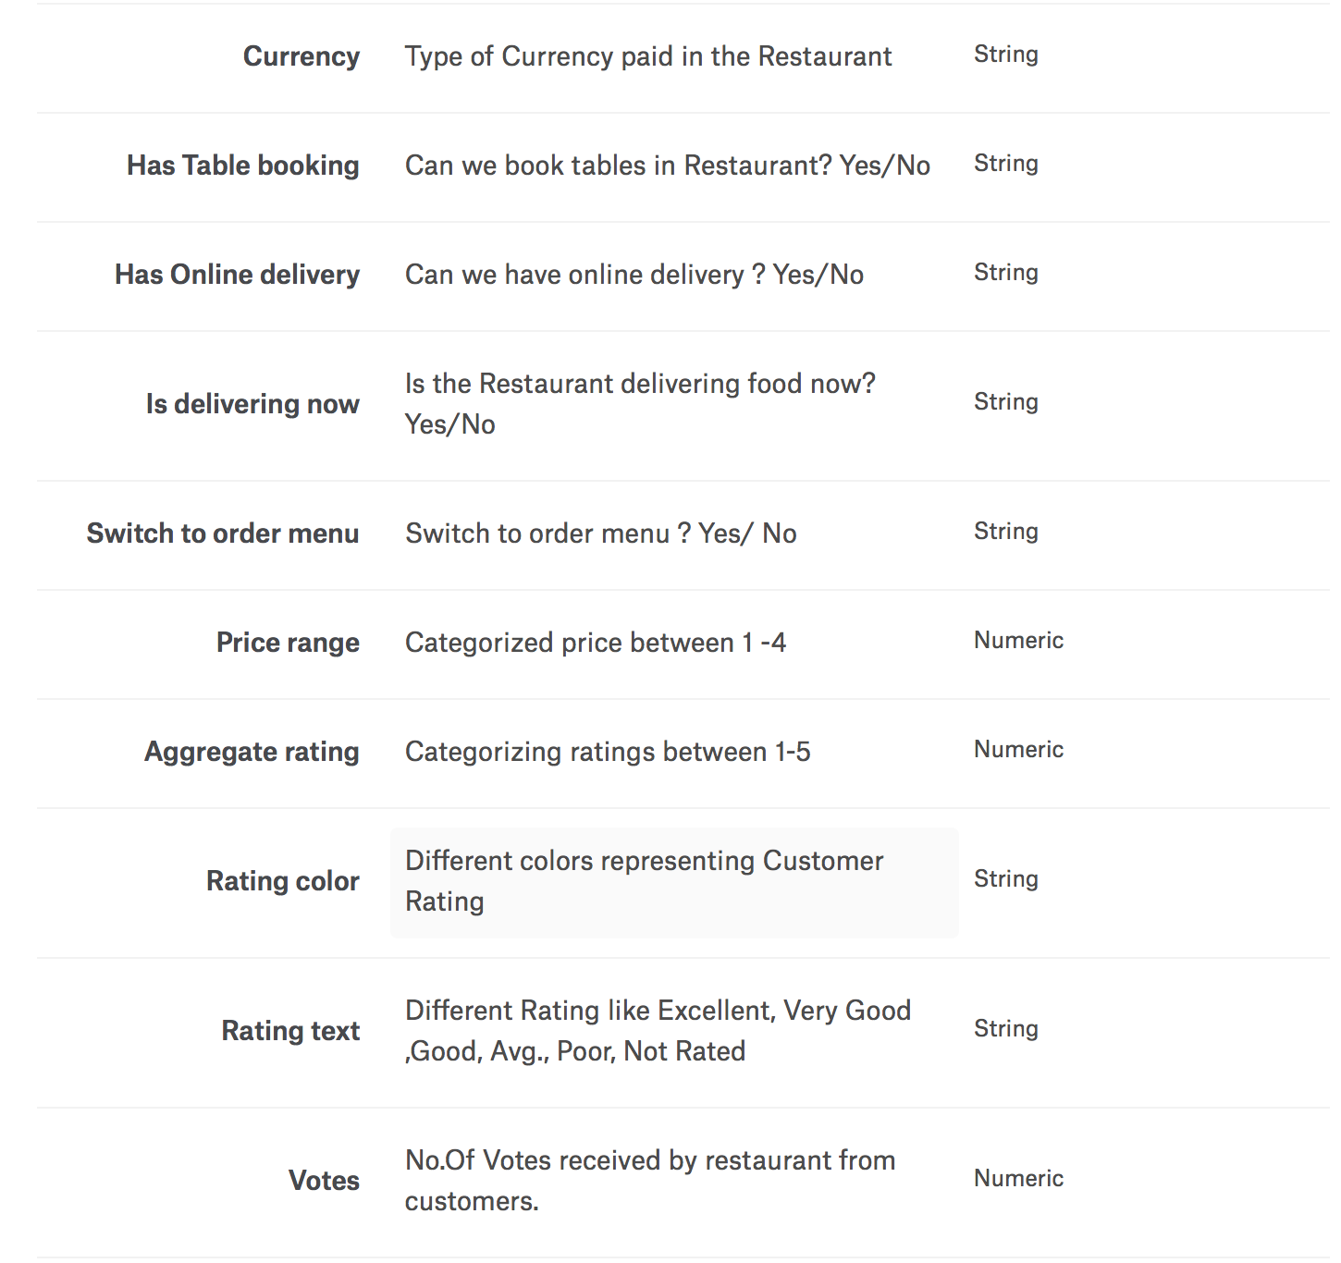

**B) Data Cleaning:**

**# Deleting/Removing irrelevant columns**

The dataset has two similar columns with the column names as “Locality” and “Locality.Verbose”. We removed one unwanted column(“Locality” which had less detailed data) and cleaned the data.

**Before:**

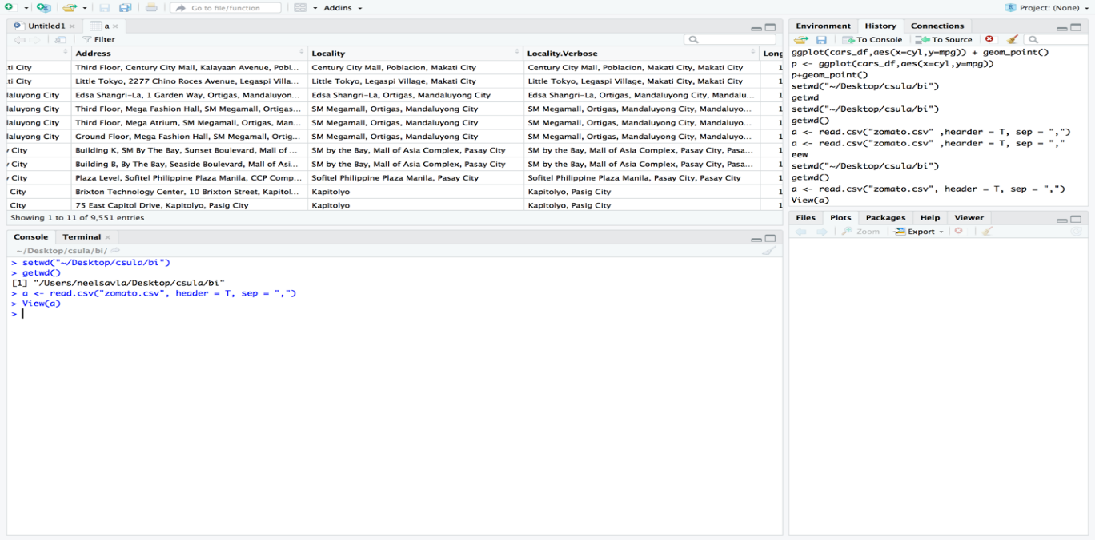

**After:** 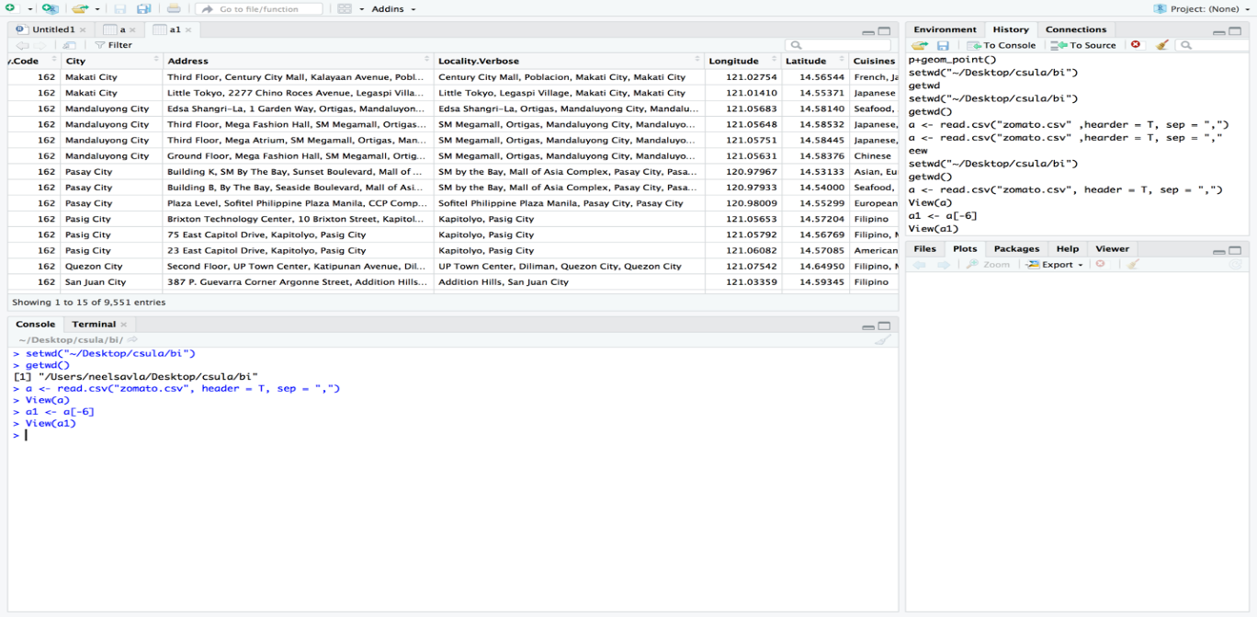

**# Combining Columns**

Combining latitude and longitude to a single column named location using unite function and installing “tidyr” package.

**Before:**

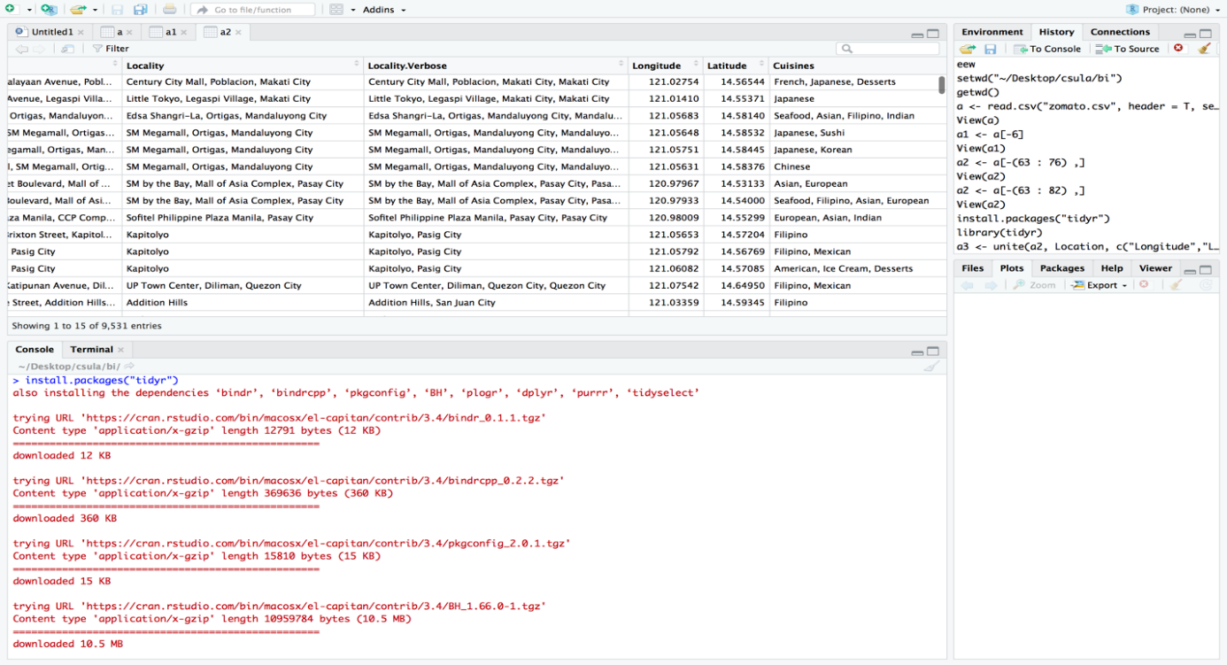

**After:**

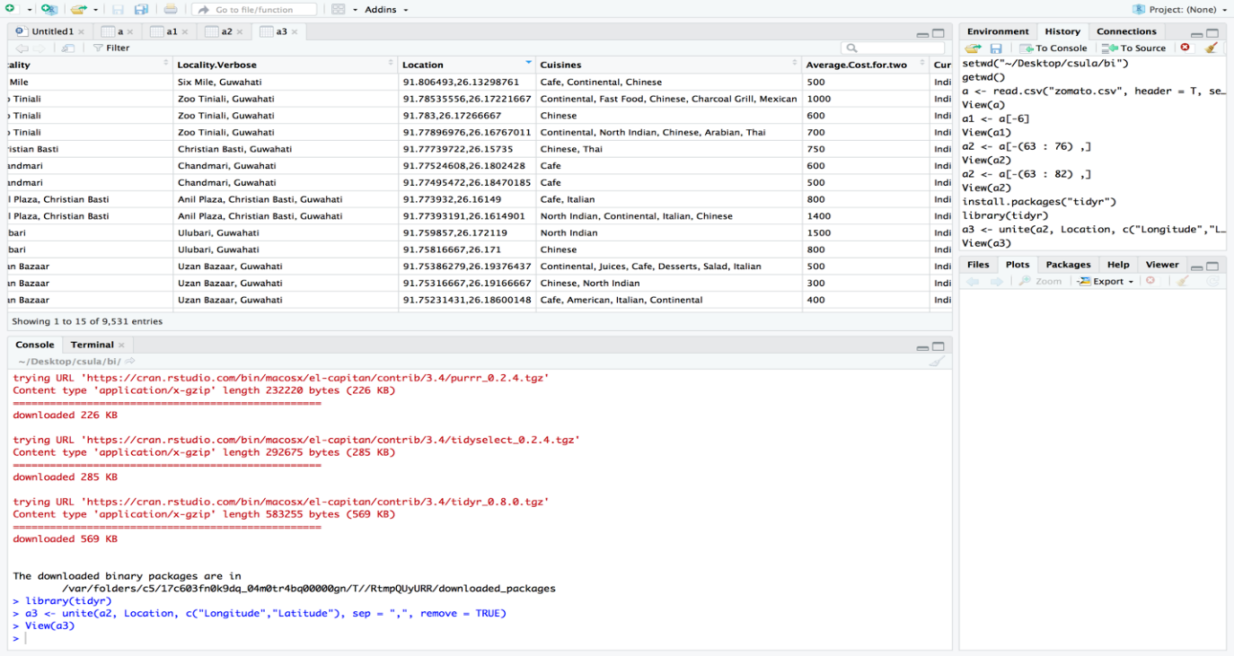

**# Removing Null Values :**

Removing Null Values and replacing with mean values in price range column.

**Before:**

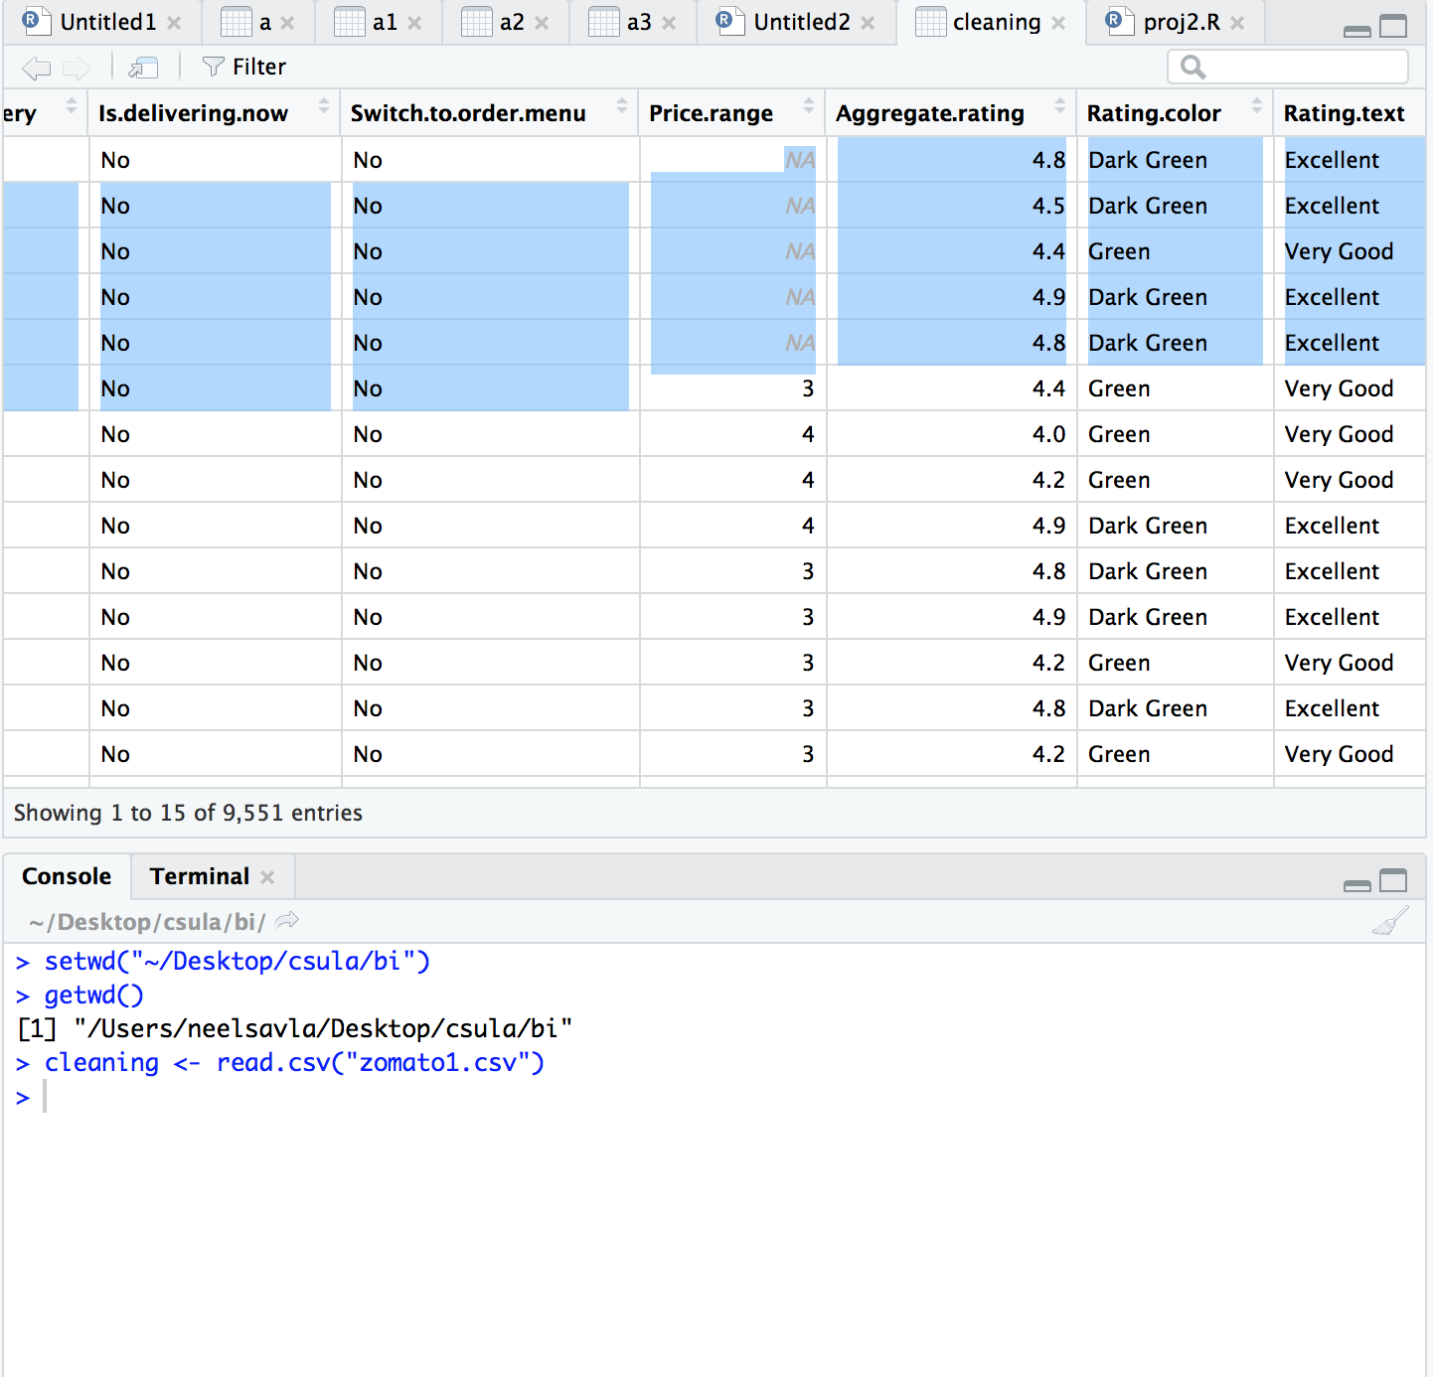

**After:**

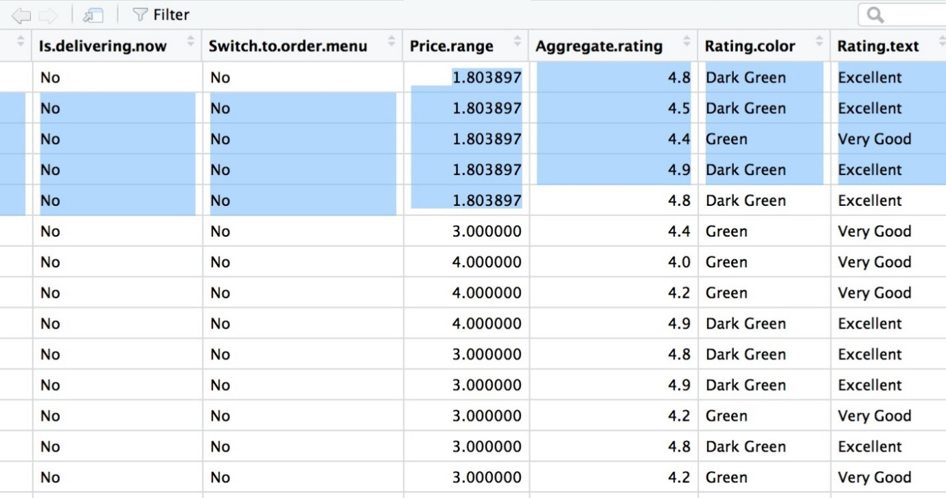

**C) Data Visualizations:**

**#Finding the Average cost of top 10 restaurants ?**

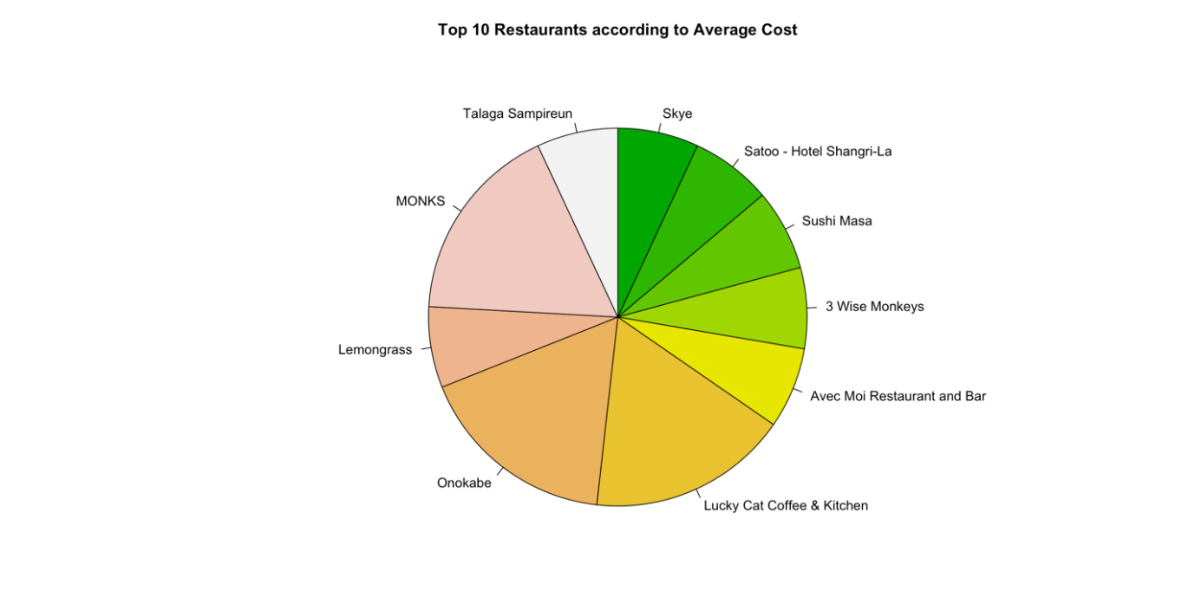

(Highlights from RScript – plotrix, plyr, pie chart)

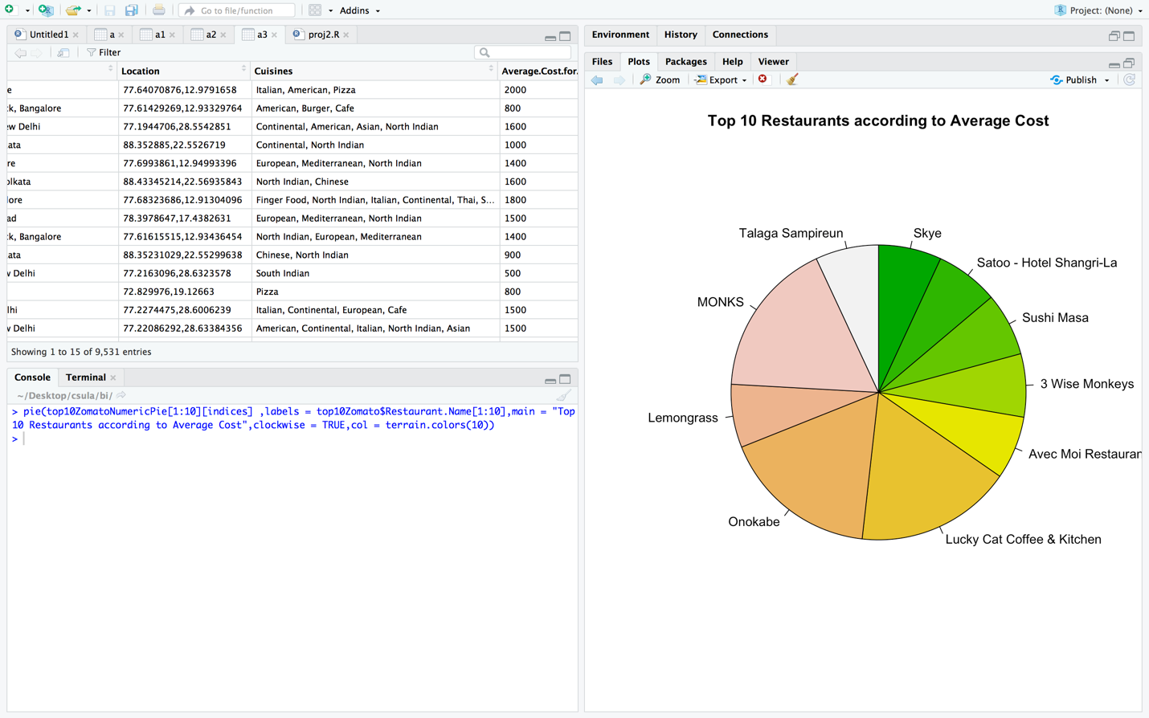

|  |
| --- |
| With the use of **R-Script** we have analysed the facts about the restaurant wise average cost proportion in above pie chart. It shows the average cost for two people of top ten restaurants. We can see the names of restaurants for which the average cost of two persons for top ten restaurants. Maximum is Lucky cat coffee & kitchen followed by Monks, Onokabe, Lemongrass, 3 wise monkeys, Sushi masa, Skye, Avec moi restaurant, Satoo – hotel Shangri la. By looking at this statistics, we can analyze the top 10 restaurants according to average cost. |

**# Different types of Customer ratings of all the restaurants ?**

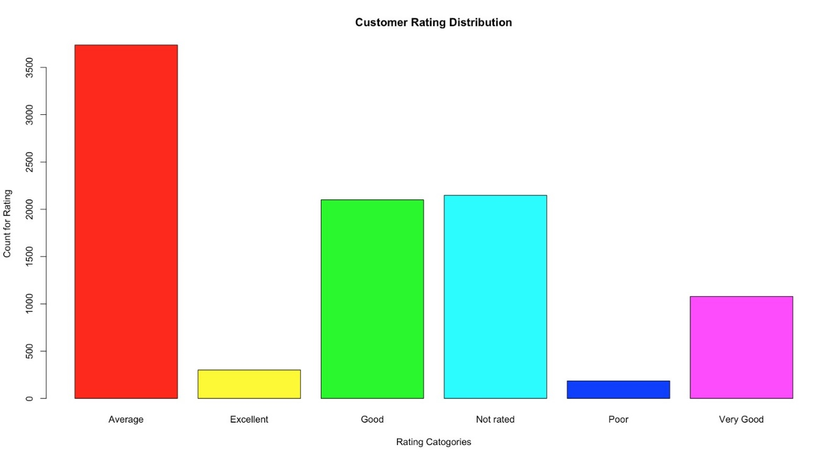

(Highlights from RScript –plotrix, plyr, Bar chart)

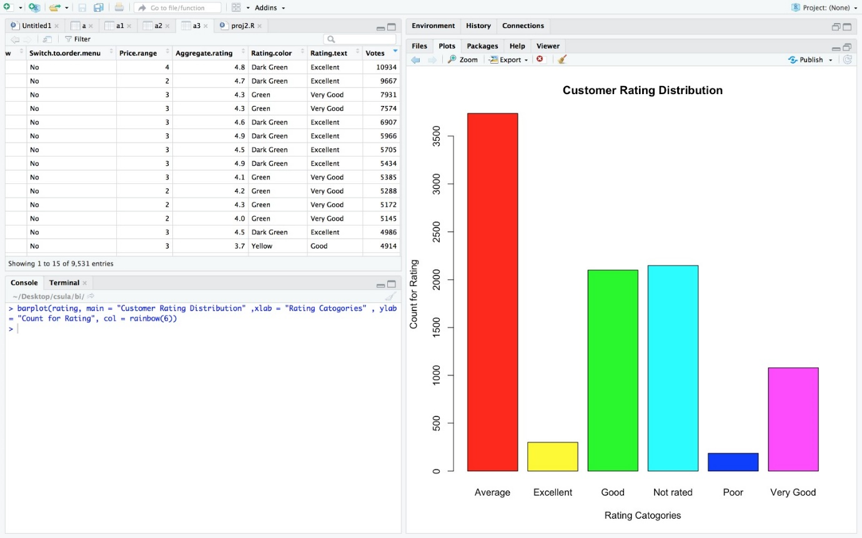

In the above Bar chart, we have tried to analyse the customer rating of all the restaurants. We can analyse that, here the rating categorised in various dimensions that is Average, Excellent, Good, Not Rated, Poor, Very Good. Maximum restaurants are rated “Average” by the customers with the count for rating greater than 3500 followed by Not Rated, Good, Very Good, Excellent, Poor has been rated by customers

|  |  |  |
| --- | --- | --- |
| **Rating Categories** | **Aggregate rating** | **Rating Color** |
| Excellent | = 4.5> | Dark Green |
| Very good | 4 to 4.5 | Green |
| Good | 3.5 to 3.9 | Yellow |
| Average | 2.5 to 3.4 | Orange |
| Poor | 1 to 2.5 | Red |
| Not Rated | Nil | White |

**# Finding how much Customers voted of top ten restaurants ?**

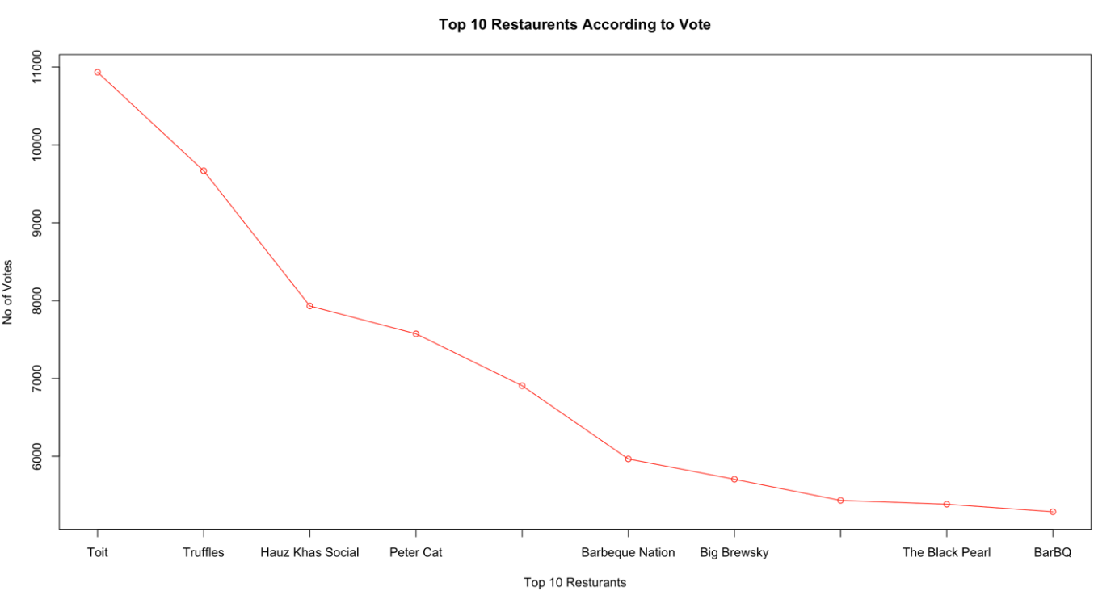

(Highlights from RScript –plotrix, plyr, Line chart)

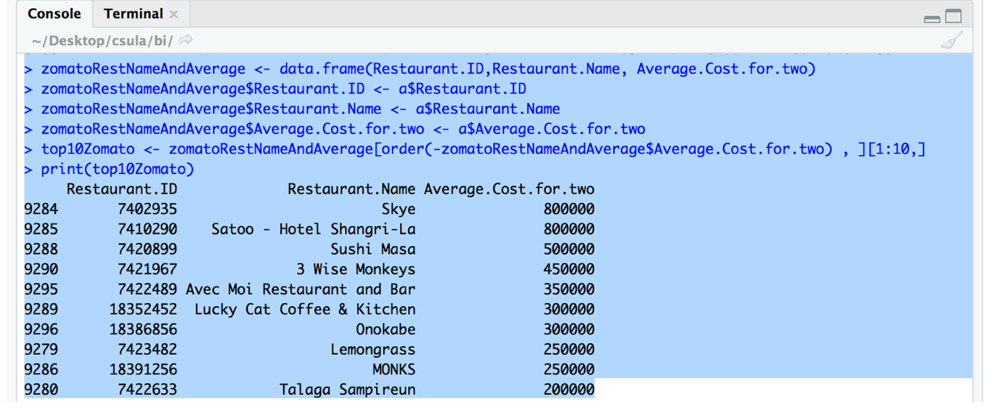

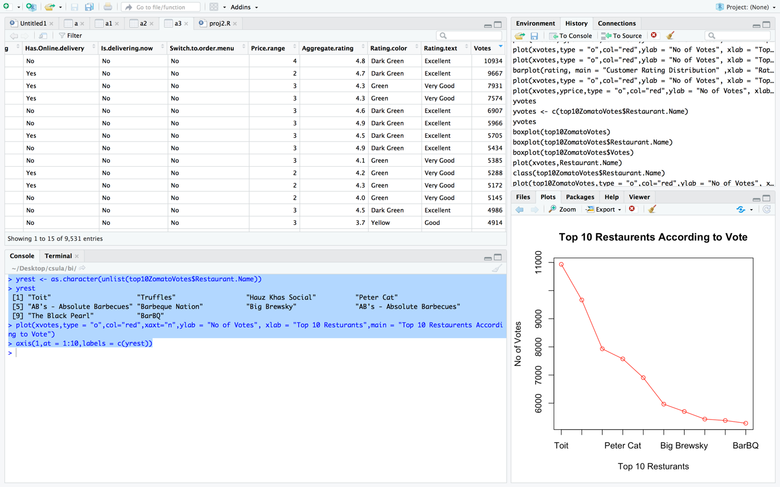

In the above line chart, we have tried to analyse the customer votes of all the restaurants. We can analyse that, here the Maximum vote 10934; Minimum vote 0. The Customer votes of top 10 restaurants; where, for TOIT there are votes **10934**. By looking at this statistics, we can analysis the top 10 restaurants according to customer votes.

**# Finding Overall Customer ratings for all the restaurants ?** 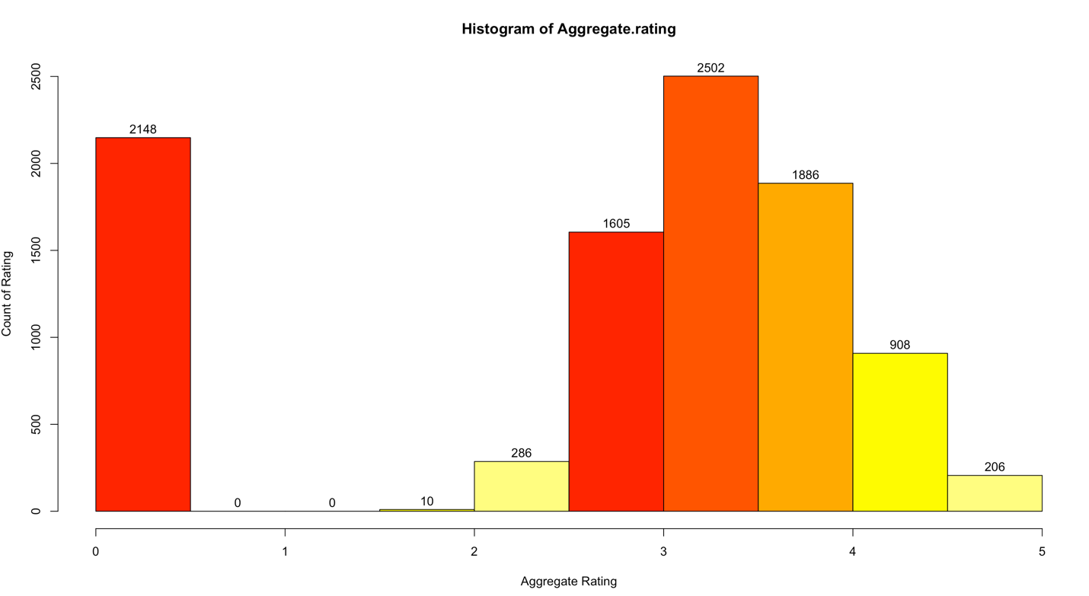

In the above histogram, we have tried to analyse the overall customer ratings of all the restaurants where horizontal axis indicates aggregate ratings and vertical axis indicates count of rating. Rating is ranged between 0 to 5.

By analysis of the above data, we found that the highest count of rating is 2502 which is indicated between 3-4 in restaurants aggregate rating

**# Finding Customer preferable price range on all the restaurants ?**

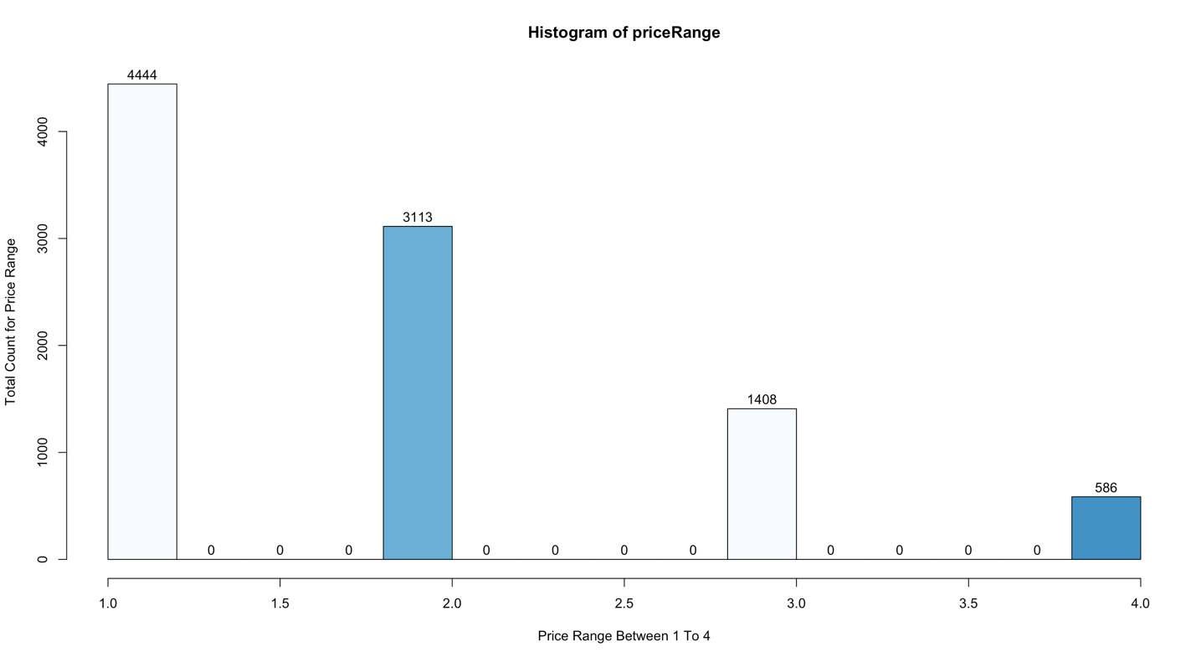

In the above graph, we have tried to compare between price range and the count of price range. So that we can analyze the price range which has been focused by the customer.

Horizontal axis indicates the price range which ranges from 0 to 5000 and vertical axis indicates the total count of price which ranges from 1.0 to 4.0. (1= Lowest, 4= Highest)

From the above graph, we found that 4444 restaurants falls between 1 – 1.5 ratings and 586 restaurants falls between 3.5 – 4.

D. **Statistical Summary and Functions**

**Function:**

User Defined Function:

This function is used to switch histogram graph for price range and aggregate rating, means if we call the function changecolorfn() with value if x as 1(i.e. changecolorfn(1)) then it will give a histogram for aggregate ratings where as is the value of x is any number other then 1 then it will give a histogram for price range also with different colours.

Output when changecolorfn(1) :

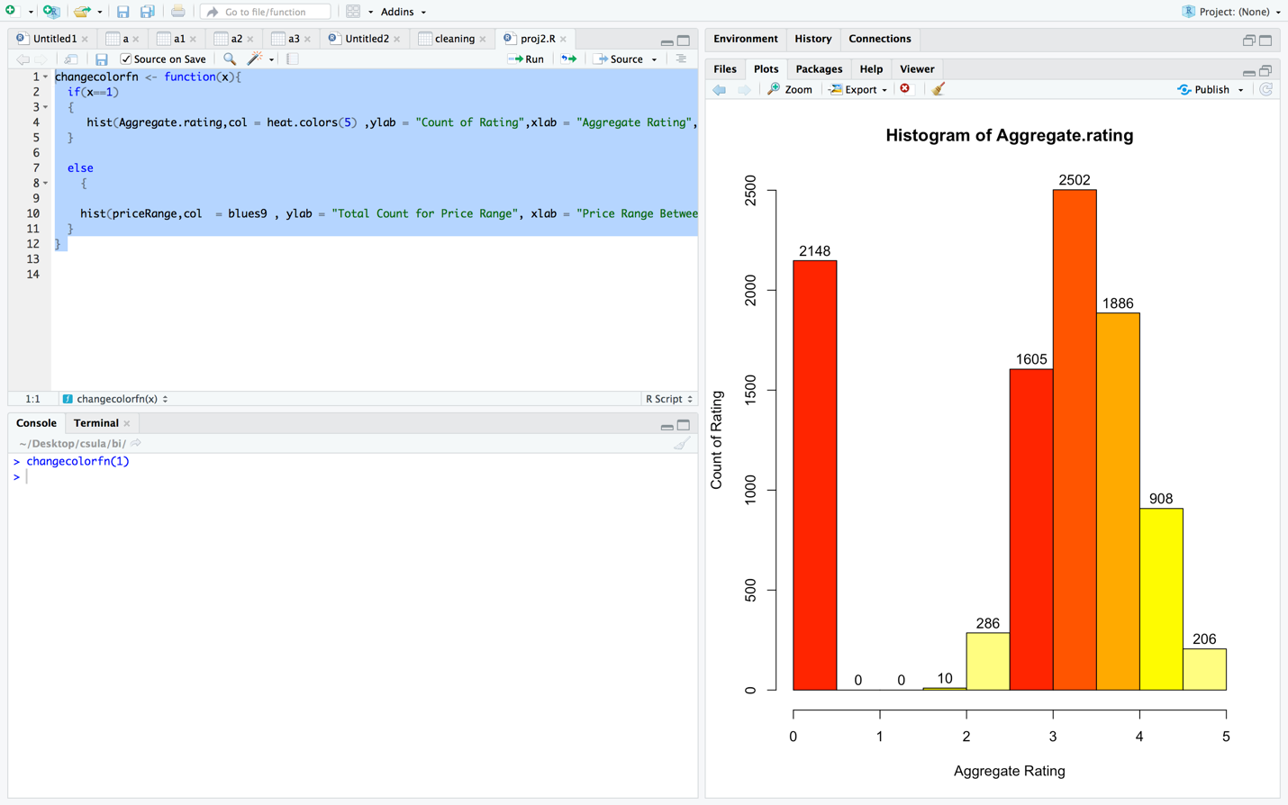

Output when changecolorfn(2) or any number :

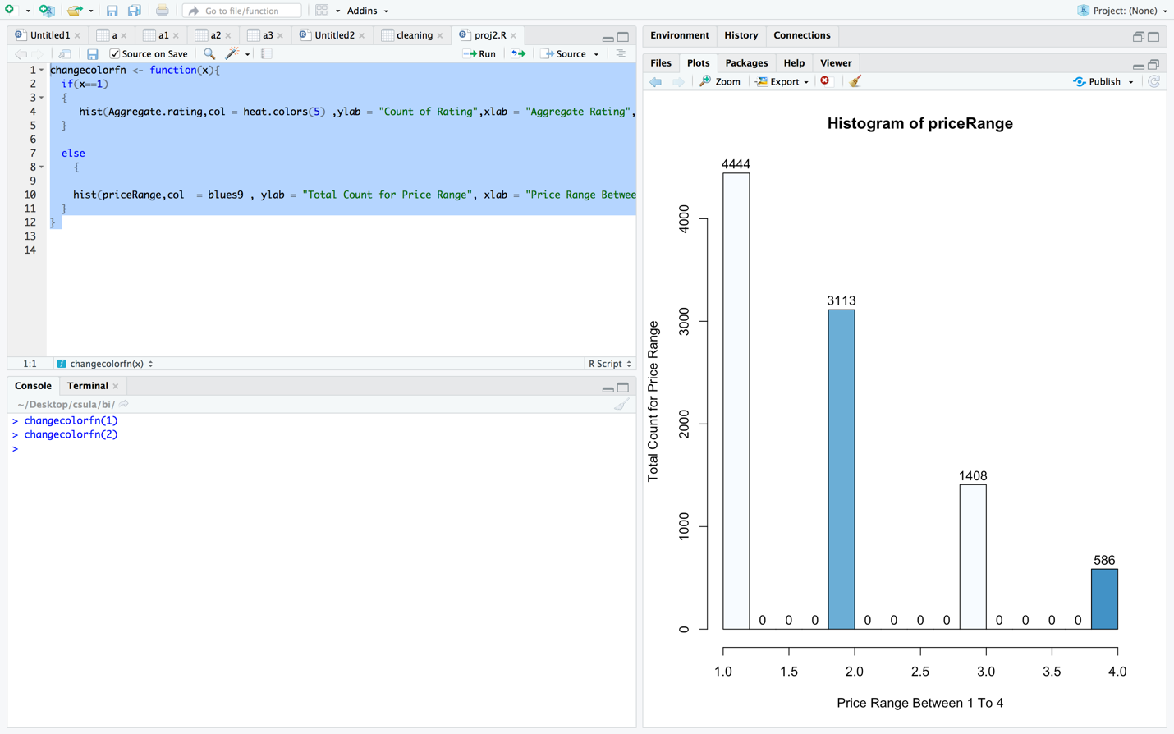

Summary :

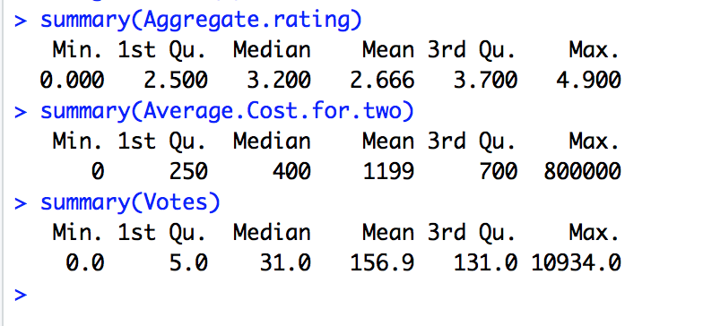

🡺**R Code for all the Analysis and Visualizations:**

**DATA - CLEANING :**

>setwd("~/Desktop/csula/bi")

>getwd()

[1] "/Users/neelsavla/Desktop/csula/bi"

> a <- read.csv("zomato.csv", header = T, sep = ",")

>View(a)

> a1 <- a[-6]

>View(a1)

>install.packages("tidyr")

>library(tidyr)

> a3 <- unite(a2, Location, c("Longitude","Latitude"), sep = ",", remove = TRUE)

>View(a3)

> cleaning <- read.csv("zomato1.csv")

> View(cleaning)

> mean(cleaning$Price.range,na.rm = TRUE)

[1] 1.803897

> cleaning$Price.range[is.na(cleaning$Price.range)] = mean(cleaning$Price.range, na.rm = TRUE)

> View(cleaning)

**PIE - CHART:** **“Average cost for two of top 10 restaurants”**

> top10ZomatoNumeric <- data.frame(Restaurant.ID,Restaurant.Name, Average.Cost.for.two)

> top10ZomatoNumeric$Average.Cost.for.two <- a$Average.Cost.for.two

> top10ZomatoNumeric$Restaurant.ID <- a$Restaurant.ID

> top10ZomatoNumeric$Restaurant.Name <- a$Restaurant.Name

> top10ZomatoNumericPie <- top10ZomatoNumeric[order(-top10ZomatoNumeric$Average.Cost.for.two) , ][1:10,]

> print(top10ZomatoNumericPie)

Convert to numeric :

> class(top10ZomatoNumericPie)

[1] "data.frame"

> top10ZomatoNumericPie <- as.numeric(as.character(unlist(top10ZomatoNumericPie)))

> class(top10ZomatoNumericPie)

[1] "numeric"

> pie(top10ZomatoNumericPie[1:10][indices] ,labels = top10Zomato$Restaurant.Name[1:10],main = "Top 10 Restaurants according to Average Cost",clockwise = TRUE,col = terrain.colors(10))

**BAR - CHART: “Customer ratings of all the restaurants”**

>head(a$Rating.text)

[1] Excellent Excellent Very Good Excellent Excellent Very Good

Levels: Average Excellent Good Not rated Poor Very Good

> rating <- table(a$Rating.text)

> barplot(rating, main = "Customer Rating Distribution" ,xlab = "Rating Catogories" , ylab = "Count for Rating", col = rainbow(6))

**LINE-CHART: “Customer votes of top 10 restaurant”**

> yrest <- as.character(unlist(top10ZomatoVotes$Restaurant.Name))

> yrest

[1] "Toit" "Truffles" "Hauz Khas Social" "Peter Cat"

[5] "AB's - Absolute Barbecues" "Barbeque Nation" "Big Brewsky" "AB's - Absolute Barbecues"

[9] "The Black Pearl" "BarBQ"

> plot(xvotes,type = "o",col="red",xaxt="n",ylab = "No of Votes", xlab = "Top 10 Resturants",main = "Top 10 Restaurents According to Vote")

> axis(1,at = 1:10,labels = c(yrest))

**HISTOGRAM: “Overall Customer ratings on all the restaurants”**

changecolorfn(1)

**HISTOGRAM: “Customer preferable price range on all the restaurants”**

changecolorfn(2) OR changecolorfn(3) OR changecolorfn(….n except 1)

**USER DEFINED FUNCTION : “changecolorfn(x)”**

**HISTOGRAM: “Overall Customer ratings on all the restaurants”**

changecolorfn <- function(x){

if(x==1)

{

hist(Aggregate.rating,col = heat.colors(5) ,ylab = "Count of Rating",xlab = "Aggregate Rating",labels = TRUE)

}

**HISTOGRAM: “Customer preferable price range on all the restaurants”**

else

{

hist(priceRange,col = blues9 , ylab = "Total Count for Price Range", xlab = "Price Range Between 1 To 4",labels = TRUE)

}

}

**Statistical Averages Of Data : “Summary Of Aggregate Customer Rating, Average Cost to two person, Customer Votes for Restaurant”**

> summary(Aggregate.rating)

Min. 1st Qu. Median Mean 3rd Qu. Max.

0.000 2.500 3.200 2.666 3.700 4.900

> summary(Average.Cost.for.two)

Min. 1st Qu. Median Mean 3rd Qu. Max.

0 250 400 1199 700 800000

> summary(Votes)

Min. 1st Qu. Median Mean 3rd Qu. Max.

0.0 5.0 31.0 156.9 131.0 10934.0

**An example of Pie Chart Script in R(Click On the Image Below And Download the R**

**File):** [**https://drive.google.com/open?id=1F304RkF0zu6DIeHZOfkYoXYNpItq-0_w**](https://drive.google.com/open?id=1F304RkF0zu6DIeHZOfkYoXYNpItq-0_w)

[](https://drive.google.com/file/d/1F304RkF0zu6DIeHZOfkYoXYNpItq-0_w/view)

**References:**

# 1. Patodi, Shaneel. (Nov 2016). “Presentation on zomato”. Retrieved from “<https://www.slideshare.net/mobile/ShaneelPatodi/zomato-presentation>”.

# 2. “CASE STUDY- Zomato: An Indian Startup acquiring the world”. Retrieved from “<http://dsim.in/blog/2015/04/14/zomato-an-indian-startup-acquiring-the-world>”.

3. Ravish , Vishal. (Aug 2017). “Case Study on Zomato : A Global Indian Company”. Retrieved from “<https://googleweblight.com/i?u=https://www.whizsky.com/2017/08/case-study-zomato-global-indian-company/&hl=en-IN>”.

4. Mathur, Sneha. (July 2015). “Zomato: An Indian startup acquiring the world”. Retrieved from “<https://googleweblight.com/i?u=https://www.digitalvidya.com/blog/zomato-an-indian-startup-acquiring-the-world/&hl=en-IN>”.